# Assignment 7: Use CSS Positioning, Pseudo-Elements, and Pseudo-Classes to Create Tooltips



Background

This assignment is designed to familiarize you with using CSS positioning, pseudo-classes, and pseudo-elements to create advanced interactive features for your websites. A proper tooltip for production websites would require special accessibility considerations as well as a healthy amount of JavaScript; it is not feasible to make an accessible and fully-featured tooltip implementation with HTML and CSS alone. This assignment is meant to be an exercise for students to practice specific CSS skills, not a test of production web components, so do not fret over making your tooltips production-ready. If you are interested in learning how to make a proper tooltip, or why a pure HTML/CSS tooltip is insufficient, see [Sarah Higley's blog post](https://sarahmhigley.com/writing/tooltips-in-wcag-21/).

Setup

Create a git repository titled m7-hw7-lastname-firstname and clone the repo to your computer. Copy the **contents** of the unsolved folder into your repository. Ensure the index.html file is in the **root** of your repository so that it deploys to GitHub pages properly.

Instructions

Use the provided code in the unsolved folder to implement a sticky banner, a drop cap, and tooltips on the webpage. In order to receive full-credit for this assignment, you must:

1. Use position: sticky to make the section.hero element stick to the top of the page when scrolling down. Refer to the gif at the top of the page.
2. Create a drop cap for the first letter of the first p tag in the article element.
   * A drop cap is an enlarged first letter of the first word in a text. Usually seen at the start of a chapter in a book.   
     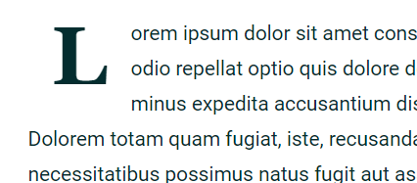
3. Finish the tooltip code in the CSS file so that when hovering over or focusing the red text causes the text within the inner span tag to appear above as a word bubble. Again, refer to the gif at the top of these instructions for a visual example.
4. Deploy the finished site to GitHub pages.

Deployment

Your code must be deployed to GitHub Pages. To deploy a repository to GitHub pages you must:

1. Ensure your repository has an index.html file in the root directory.
2. Navigate to the settings section of the repository.
3. Click on pages in the left navigation menu.
4. Under source click the dropdown and select your master or main branch.
5. Click save.

Your site should be deployed to <your github username>.github.io/<your repository name> in 5-10 minutes.